Title of the extended abstract

First authorª, Second author^{b}, Third author^{c,}
ªFirst author affiliation, Address, City and postcode, Country
^{b}Second author affiliation, Address, City and postcode, Country
^{c}Third author affiliation, Address, City and postcode, Country

Abstract
Insert your abstract here. The word limit for the abstract is 250 words (excluding references). The formatting should be kept same as template. Maximum of one figure and five references are allowed.

Text abstract text abstract text abstract text abstract text abstract text abstract text abstract text abstract Text abstract text abstract text abstract text abstract text abstract text abstract text.
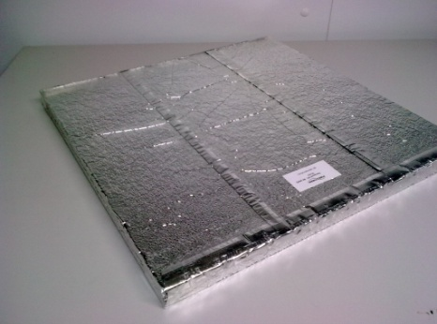
Fig. 1. Picture of a vacuum insulation panel (VIP), Text picture text picture text picture text

Text plain text plain text plain text plain text plain text plain text plain text plain text plain text plain text plain text plain text plain text plain text plain text plain text plain text.

Keywords: Write 4 keywords separated by semicolons;

References
[1]. R. Caps, J. Fricke, Thermal conductivity of opacified powder filler materials for vacuum insulations, Int. J. Thermophys. 21 (2000) 445–452. https://doi.org/10.1023/A:1006691731253.
[2]. S. Verma, H. Singh, Vacuum insulation panels for refrigerators, Int. J. Refrig. 112 (2020) 215–228. https://doi.org/10.1016/j.ijrefrig.2019.12.007.
[3] Avery Dennison Israel Ltd, INDUSTRIAL FILMS Metallized Laminates for Vacuum Insulation Panels, 2019 [online] Kibbutz Hanita. Available at: https://hanita.averydennison.com/na/en/home/customer-tools/vip-laminates-ds-td.html.
Accessed 10 July 2022.

Corresponding author email address: abc@institute.xyz

